Impact of Full Replacement with Consumer Driven Health Plans on Total Health Care Cost and Use of Preventive Services

Abstract

Enrollment in Consumer Driven Health Plans (CDHPs) continues to grow with nearly eight million United States enrollees in 2008. In this research study, we look at four large employee groups where all of the traditional health plans were replaced with CDHPs. This study has two goals related to understanding the effect of full replacement: (1) What is the impact of full replacement of traditional managed care plans with CDHPs on total health care costs? (2) What is the impact of full replacement on the utilization of preventive care services? The issue of selection bias will not arise as employees do not have the options of choosing other health plans. Data for our study came from four large employers with 61,438 covered lives. Our study has several significant findings. Most important, full replacement with CDHPs achieved a level of cost savings not seen in previous empirical studies where consumers had other plan choices. Second, total replacement with CDHPs led to a decrease or had a neutral effect on prevention. Few of the changes in preventive care measures were statistically significant. At best, consumerism affects prevention in a neutral fashion. At worst, consumers use less preventive care measures.

Final Technical Report for DHHS Contract HHSP23320054301ER

December 31, 2008

Stephen T. Parente, Ph.D.
Roger Feldman, Ph.D.
Yi Xu, B.S.

JEL Classification: I1

This study was funded by US DHHS Contract HHSP23320054301ER. All work completed in this analysis is the sole responsibility of the authors.
Impact of Full Replacement with Consumer Driven Health Plans on
Total Health Care Cost and Use of Preventive Services

Introduction
Several large employers have replaced their traditional health insurance plans with CDHPs. For example, UnitedHealth Group, as an employer, switched in 2005 from offering PPO and POS plans and a health reimbursement account (HRA) with almost no enrollees, to a CDHP with only one HRA and one health savings account (HSA). The impact of this change could be quite different than what we have observed previously (Parente, Feldman, and Christianson, 2004; Feldman, Parente and Christianson, 2007; Parente, Feldman, and Chen, 2008) when a CDHP plan was made available among other choices such as PPO and POS plans..
In particular, prior research on CDHPs has had to overcome the problem of ‘selection bias’ – people who voluntarily join a CDHP being different in unobserved ways from those who stayed with traditional plans, with those differences potentially affecting the estimates of CDHP effects on utilization and costs. Selection bias can over- or under-state the true CDHP effects on cost and use, depending on whether healthy or unhealthy employees choose the CDHP plans (Parente, Feldman, and Christianson, 2008). In this study, we look at four large employee groups where all the traditional health plan options were replaced with CDHPs. The issue of selection bias will not arise in these ‘full replacement’ settings. This research study has two goals related to understanding the effect of full replacement on health care cost and utilization:
- What is the impact of full replacement of PPO/POS plans with consumer driven health plans (CDHPs) on total health care cost?
- What is the impact of full replacement on the utilization of preventive care?
Previous Research
Evidence has revealed that higher cost-sharing will reduce medical care consumption (Newhouse, et al., 1993). Because CDHPs introduce cost-sharing in the form of high deductibles, the implementation of CDHPs may moderately reduce health care use and costs. In fact, CDHP enrollees have lower expenditures than some traditional insurance plans, but higher expenditures than HMO enrollees (Parente, Feldman, and Christianson, 2004; Lo Sasso, et al., 2004). Additional comparisons have shown that CDHP enrollees make fewer physician visits than those in a POS plan (Feldman, Parente, and Christianson, 2007). Another study assessing the effect of offering CDHP options found that employees of Humana, Inc. who chose CDHPs were more likely to have no recent medical visits compared with reference PPO and HMO enrollees (Fowles, et al., 2004).
However, none of these studies has investigated the impact of full replacement on health care use and cost. The Humana study cited above also found that CDHP enrollees were healthier, and therefore the reduction in physicians’ visits for CDHP enrollees may have been due to better health rather than the plan’s financial incentives.
One of concerns about the impact of CDHPs is that a reduction in physician visits may result in less use of preventive care. The assumption behind this concern is that the CDHP benefit design provides a disincentive to pay for preventive services out-of-pocket to reduce overall financial exposure. Thus, a complementary test for the cost and use impact of full replacement by CDHP health plans is whether preventive services are also affected.
A small but rapidly-growing literature has examined the effect of benefit design on the use of preventive services. Busch, et al. (2006) compared the use of preventive services among employees in a traditional health plan who experienced a change in plan design – lower cost-sharing for preventive services and higher cost-sharing for other services – with that of a control group from the same company whose benefits did not change. Health care costs for the affected employees fell 5 percent while those for the control group rose 4 percent. There were no changes in rates of preventive care use. The authors concluded (p. 1529), “The evidence suggests that differential cost sharing can be used to preserve the use of critical health care services.”
Rowe, at al. (2008) compared use of preventive, cancer screening, and diabetic monitoring services among continuous enrollees in a CDHP for three years and a matched group of PPO enrollees who had free preventive and screening services. According to the authors (pp. 119-120), “…initially and over time, people enrolled in CDHPs such as those we studied do not underuse preventive services to any greater degree than do those in traditional PPOs.”
Pollack, Polsky, and Mallya (2008) used vignettes to elicit physicians’ recommendations for colorectal cancer screening. They found that patients with low socio-economic status (SES) received inappropriate recommendations more often than those with high SES, but there were no differences in inappropriate recommendations for patients of either SES group in low and high-deductible plans. If physicians were told that the low SES/high-deductible patients had $700 in their Health Savings Account, these patients no longer received a higher rate of inappropriate recommendations compared with other patients.
Finally, in a full replacement study that is closest to our work, Wharam, et al. (2008) found little change in cancer screening among enrollees at Harvard Pilgrim Health Plan. Members of a high-deductible health plan did not seem to change their use of breast, cervical, and colorectal cancer screening when these tests were fully covered.
Conceptual Model
Health benefit design affects the demand for medical care, including preventive services.
Increased patient cost-sharing acts as a price increase to reduce medical care demand. Therefore, patients in high-deductible health plans should use fewer services and spend less on medical care than those in plans with low cost-sharing (Newhouse, et al., 1993). To mitigate this effect, CDHP designs often exempt preventive care partially or totally from the cost-sharing requirements imposed on other services. A partial exemption might specify a dollar limit for covered spending on preventive care; a full exemption would waive this limit on all preventive services covered by the policy.
Despite this exemption, patients in CDHPs might use fewer covered preventive services if there are strong linkages or ‘complementarities’ between acute and preventive medical care services. For example, patients seen in non-preventive physician visits may be advised to use preventive services, and the reduced frequency of the former could lead to reduced use of the latter. Evidence supports the association between the number of non-preventive physician visits and the probability of using preventive care. For example, the number of non-preventive physician visits has been found to be associated with the likelihood of influenza vaccination among diabetic adults (Egede, 2003). These studies suggest that CDHP enrollees might use fewer preventive services than those in comparison PPO/POS plans, despite the CDHP exemption of preventive services from cost-sharing.

Data
Data for our study came from four large employers with 61,438 covered lives. We had access to medical and pharmacy claims and enrollment data for two years: pre- and post-full replacement of their PPO/POS plans with CDHPs. Firm #1 adopted an HSA and HRA in 2005. In 2004, it had PPO and POS plans and an HRA with almost no enrollees. Firm #2 adopted an HRA in 2004 and had no prior CDHP experience in 2003. Firms #3 and #4 adopted CDHP plans in 2006 and had no prior experience with CDHPs. Firm #3 chose only an HSA while Firm #4 adopted an HRA and HSA. Thus, Firms #2 and #3 provide insights into ‘pure’ HRA and HSA replacement, respectively. Firms #1 and #4 illustrate the impact of mixed HRA and HSA replacement.
We selected employees who were enrolled in the employers’ health benefits programs for two continuous years. This provided us with a cohort to identify the pre- and post-full replacement effects of the CDHP plan design. Firms #1 and #3 had the highest cohort retention rates with 60.8% and 61.6%, respectively, of the first-year population also being in the second year. The retention rate for Firm #2 was 52.9%, and Firm #4 had the lowest retention rate of all the employers, at 47.2%. The selection of a cohort reduced our total sample to a population-weighted 57% of those enrolled in the pre-full replacement year. These cohorts include not only the employees but their spouses and dependents. As a result, even if a firm has relatively low employee turnover, changes in coverage among spouses and dependents can substantially reduce the size of a continuous cohort.
The demographics of our study sample are described in Table 1. Firm #1 has the youngest population (29.6 years of age), while Firm #3 has the oldest population (34.1 years of age). However, the gap between the youngest and oldest firm-specific mean ages is just under five years. Firm #1 has the greatest share of female enrollees of the four firms. In addition to having the oldest enrollees, Firm #3 is also associated at baseline with the most chronic illnesses and the presence of serious health events that could be catastrophic. Firm #2 has the greatest share of subscribers (70.7%) and Firm #3 has the greatest share of dependents (37.3%).

Table 1 – Study Sample Demographics
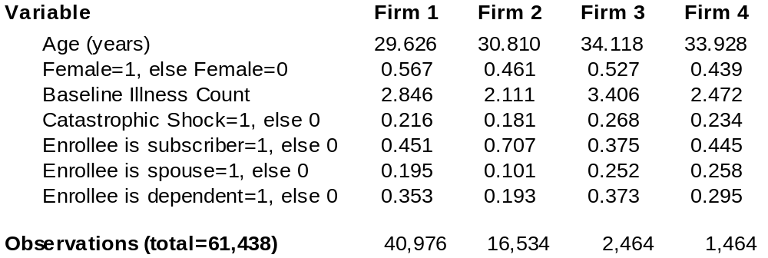
Econometric Approach
We used a two-part model to complete a difference-in-differences estimate of the effect of CDHP full replacement on total expenditures and the probability of preventive care use for a set of specific measures: any preventive care visit; colonoscopy screening for members aged 40 to 64; mammography screening for women aged 40 to 64; and cervical cancer screening for women aged 24 to 64.
Since all of the employers in our study were CDHP ‘adopters’, we did not have a control group of non-CDHP firms. Instead, we used each firm as its own control and compared pre- versus post-full replacement medical care use and spending. As noted above, one company implemented CDHPs in 2004, one in 2005 and two others did this in 2006. We needed to control for this difference, so we estimated:
(1)
where Y_{t} is the dependent variable in year t, POSTYEAR indicates the data come from the year after CDHP adoption, EMPLOYER is a set of fixed effects that control for unmeasured differences in benefit generosity and employee health status across the employers, DEMOGRAPHICS is a set of employee demographic characteristics, and 2005 BASEYEAR indicates that the firm still had traditional health plans in 2005 (i.e. it implemented full replacement with CDHPs in 2006). After controlling for employee demographics and the employer fixed effects, the base-year value of the dependent variable for those firms would be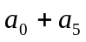. The effect of full replacement and medical cost inflation is captured by 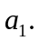 Hence we cannot identify the effect of full replacement separately from that of medical cost inflation. However, assuming that all firms were subject to the same cost trend (roughly 7-8 percent per year), we can infer the CDHP effect as the difference. Finally, the estimated coefficient 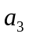allows the CDHP-and-inflation effect to differ across employers.

Results
We present three levels of results. First, we present bivariate results of CDHP full replacement for expenditures and prevention. Second, we provide a summary of our multivariate regression results. Third, we interpret specific regression results for each of the key dependent measures examined.

Table 2 – Descriptive Statistics of Expenditures
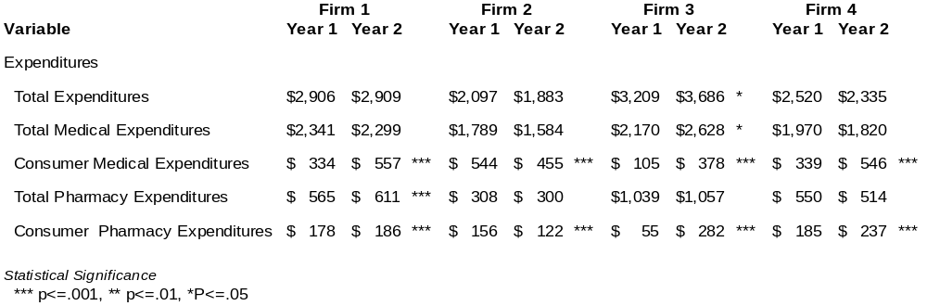
In Table 2, five measures of expenditures are compared across the four firms in their pre- and post-years described hereafter as Year 1 and Year 2. With respect to total expenditures, only Firm #3 had a significant (p<=.05) increase in average per enrollee expenditure from $3,209 to $3,686. There was little statistically significant difference in total medical expenditures, though most went down. Consumer out-of-pocket expenditures increased significantly for all firms except Firm #2, which had a decrease. With respect to pharmacy costs, Firm #1 had a statistically significant increase, while Firms #2 and #4 had a small decrease. Consumer pharmacy expenditures increased for all firms except Firm #2, where they decreased. Firm #2 also was the only firm to have full replacement with an HRA. With respect to consumer medical expenditures, Firm #3 had individuals with the greatest increase. Firm #3 is also the only employer with HSA full replacement.
Table 3 presents descriptive statistics for the four measures of prevention. For preventive visits, including physical exams and well child visits, only Firm #2 has a statistically different decrease. With respect to cervical cancer screening, all but Firm #4 had a statistically significant decrease. Firm #4 has a slight, non-significant increase from 39% to 40%. Mammography use decreased significantly for Firms #1 and Firm #3. Colonoscopy had significant reduction in service in Firms #1 and #4. In the case of Firm #4, there was a 38.8% reduction in colonoscopy from 18% to 11%. It is important to note that only preventive visits are recommended for every enrollee every year.

Table 3 – Descriptive Statistics of Prevention Services
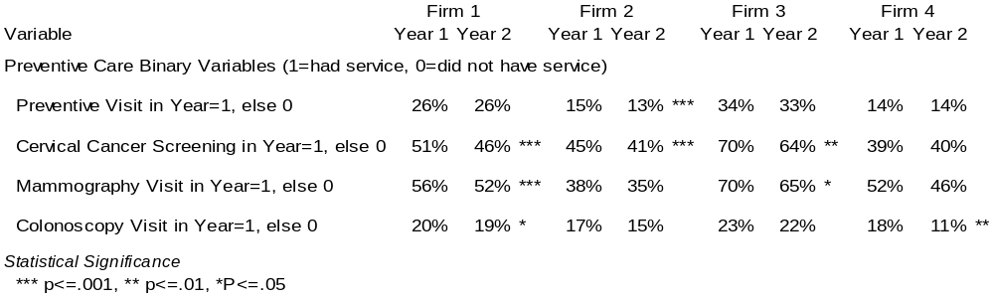
The remaining tables provide results from the econometric models described previously. Specifically, these results show the marginal effects associated with firms and other personal attributes effecting both expenditure and the use of preventive services.
Table 4 provides a summary of the firm-specific percentage changes from Year 1 to Year 2 in variables of interest. For total expenditures, no firm had a greater increase than 3.57% (Firm #3). Firm #2 had a 4.11% decrease in cost. The two firms with both HRAs and HSAs offered in Year 2 had a smaller overall impact. Most of the additional cost associated with Firm #3 was the result of an increase in medical expenditures, borne mainly by consumers. The same firm also had a substantial increase in out-of-pocket expenditures for pharmacy services, but overall expenditures on pharmaceuticals were down by 19.3%, the largest reduction among all firms for this variable. Firm #3 had the greatest reduction in cervical cancer screening, but the least reduction in mammography. The impact on the use of preventive services was less than a 1% reduction in service.
Firm #2 was associated with the greatest reduction in overall expenditures. This was due mainly to a decrease in medical care costs. The largest decrease in preventive visits was associated with Firm #2; however, Firm #2 also had the least decrease in cervical cancer screening. Across all firms, there is no obvious pattern of a trade-off between expenditures and the use of preventive services.

Table 4 – Summary of CDHP Impact – by Firm – for Expenditures and Prevention
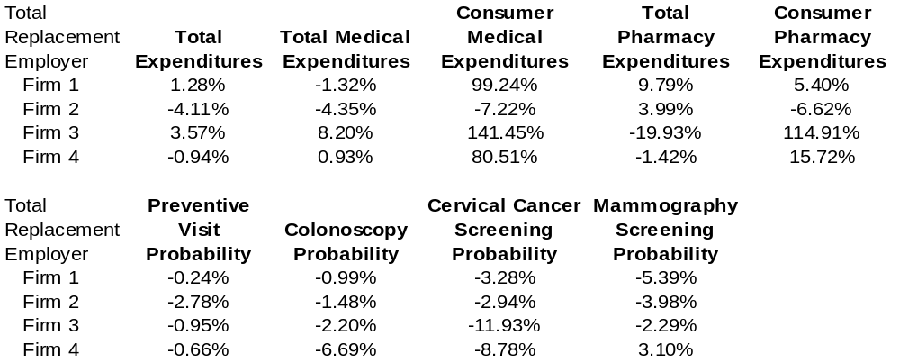
Table 4 is the product of nine separate regressions. The individual regression results are presented in Tables A1 through A9 in the Appendix. There are four notable findings from the detailed regression models. First, the demographic variables are quite significant, particularly the age and health status variables of chronic illness and presence of a major acute event. The second finding is that most of the significant firm-specific effects are associated with out-of-pocket expenditures. Third, only Firm #1 has a statistically significant impact on preventive services. Finally, the spouse and dependent variables can be important attributes associated with higher expenditures compared with the subscriber. However, the spouse and dependent variables had little impact on the use of preventive services.

Discussion
Our study has several significant findings. Most important, full replacement with CDHPs achieved a level of cost savings not seen in previous empirical studies where consumers had other plan choices. [what are your findings being compared to—also, you should be looking at the aggregate savings across all four firms, which would make your findings stronger] compared to previous work However, the cost savings were not uniform. Increases in expenditures were found in two of the four firms, although some of this increase may have been the result of general national trends in employers’ health benefit costs (Mercer, 2008). Second, total replacement with CDHPs led to a decrease in prevention. Every one of the preventive measures had at least one firm with a statistically significant decrease in preventive measures. Half of the firm/measure combinations had a significant decrease, with 5 more having a decrease, but not a significant effect. The irony is that prevention was covered at 100% reimbursement with no cost-sharing in all of the firms. Therefore, it appears that the overall reduction in medical care use had implications for decreased preventive care, despite this 100% coverage. Further investigation of the mechanisms behind this relationship is warranted. For example, patients seen in non-preventive physician visits may be advised to use preventive services, and reduced frequency of the former could lead to reduced use of the latter.
Policy Implications
This analysis finds new evidence of significant reductions in expenditures resulting from full replacement of PPO/POS plans with only CDHP plans. With respect to prevention, we find full replacement has led to a small reduction in preventive services. However, the effect of full replacement is less statistically significant than the expenditure impact. The firm that had the biggest reduction in cost was the full replacement HRA-only design (Firm #2). This is counter other findings, but in those instances, it was not a full replacement experiment that was assessed. Interestingly, the firm with the greatest increase in cost was the HSA-only design (Firm #3). Part of the story with Firm #3 could be due to the fact that it is the oldest and sickest firm of the four in our study. Firms #1 and #4 offer the best insights into the effects of a mixed CDHP offer. Firm #1 has the greatest statistical power due to its size. From Firm #1 there appears to be little concern with respect to preventive visits. However, Firm #1 experiences decreases in 3 of the 4 preventive services. The mammography rate from Firm #3 had the largest decrease among the four employers. Firm #4 experienced the largest decrease in its mammography rate; Firm #1 has the most significant decrease. Firm #4 has the smallest sample size but does have a reduction in cost as well as an decrease in mammography rates.
As employers and policy makers consider the value of CDHPs, these results provide evidence of plan design that can reduce the growth in health care inflation. With respect to prevention, there are concerns that warrant further attention. In particular, multiple years of full replacement data are required to test fully test the impact of preventive services that are not required annually. For example, of our preventive care measures, only preventives visits are generally recommended annually. Our evidence suggests that the full replacement development is worthy of future investigation and that employers contemplating austerity in light of the 2008 financial crisis will find CDHPs a reasonable cost-control alternative to not offering any employer-sponsored insurance.

Caveats
Our work is subject to several caveats. First, unlike our previous work (Parente, Feldman, and Christianson, 2004) where we had access to employees’ human resources information, we cannot control for the impact of income on cost and use of services. Second, there is unexplained market-level variation among the employers in our study. We have considered using state fixed-effects to control for this variation. The results presented here must be interpreted as early indications of the effect of CDHPs on prevention.
Additionally, the methods employed in this study should be regarded as preliminary. We plan to get more precise firm-specific affects beyond a linear probability model, to address selection more completely, and to bootstrap the correct standard errors for interaction effects on expenditure and utilization.
Finally, we hope to find firms with second and third-year post replacement data that would allow us to study the longer-run implications of full replacement. Early anecdotal evidence from Whole Foods (2007) and other firms suggest large first-year savings followed by second-year increases in costs. It will be important to obtain and analyze such data.
References
Busch, Susan H., Colleen L. Barry, Sally J. Vegso, Jody L. Sindelar, and Mark R. Cullen, “Effects of a Cost-Sharing Exemption on Use of Preventive Services at One Large Employer,” Health Affairs, 25:6 (November/December, 2006), pp. 1529-1536.

Egede, L.E., “Association between Number of Physician Visits and Influenza Vaccination among Diabetic Adults with Access to Care,” Diabetes Care, 26:9 (2003), pp. 2562-2567.

Ettner, S.L., “The Timing of Preventive Services for Women and Children: The Effect of Having a Usual Source of Care,” American Journal of Public Health, 86:12 (1996), pp. 1748-1754.

Feldman, Roger, Stephen T. Parente, and Jon B. Christianson, “Consumer Directed Health Plans: New Evidence on Spending and Utilization,” Inquiry, 44:1 (Spring, 2007), pp. 26-40.

Fowles, Jinnet Briggs., Elizabeth A. Kind, Barbara L. Braun, and John Bertko, “Early Experience with Employee Choice of Consumer-Directed Health Plans and Satisfaction with Enrollment,” Health Services Research, 39:4, Part II (August, 2004), pp. 1141-1158.

Heiss, F., D.L. McFadden, and J.K. Winter, “Mind the Gap! Consumer Perceptions and Choices of Medicare Part D Prescription Drug Plans,” NBER Working Paper W13627, Camridge, MA, November, 2007.

Lo Sasso, Anthony T., Tomas Rice, Jon R. Gabel, and Heidi Whitmore, “Tales from the New Frontier: Pioneers’ Experiences with Consumer-Driven Health Care,” Health Services Research, 39:4, Part II (August, 2004), pp. 1071-1089.

Mercer, 2008 National Survey of Employer-Sponsored Health Plans, 2008. Available for viewing at http://www.mercer.com/usplansurvey

Newhouse, Joseph P. and the Health Insurance Group, Free For All? Lessons from the RAND Health Insurance Experiment, Cambridge, MA: Harvard University Press, 1993.

Parente, Stephen T., Feldman, Roger, and Jon B. Christianson, “Evaluation of the Effect of a Consumer-Driven Health Plan on Medical Care Expenditures and Utilization,” Health Services Research, 39:4, Part II (August, 2004), pp. 1189-1209.

Parente, Stephen T., Roger Feldman, and Song Chen, “The Effects of a Consumer Driven Health Plan on Pharmaceutical Spending and Utilization: Do Three-Tier Plans Have a Competitor?” Health Services Research, 43:5 (October, 2008), pp. 1542-1556.

Parente, Stephen T., Roger Feldman, and Jon B. Christianson, “The Impact of Health Status and Price on Plan Selection in a Multiple-Choice Health Benefit Program Including HRA and HSA Options,” University of Minnesota, unpublished paper, May, 2008.

Pollack, Craig Evan, Giridhar Mallya, and Daniel Polsky, “The Impact of Consumer-Directed Health Plans and Patient Socio-economic Status on Physician Recommendations for Colorectal Cancer Screening,” Journal of General Internal Medicine, 23:10 (2008), pp. 1595-1601.

Rowe, John W., Tina Brown-Stevenson, Roberta L. Downey, and Joseph P. Newhouse, “The Effect of Consumer-Directed Health Plans on the Use of Preventive and Chronic Illness Services,” Health Affairs, 27:1 (January/February, 2008), pp. 113-120.

Sambamoorthi, U. and D.D. McAlpine, “Racial, Ethnic, and Access Disparities in the Use of Preventive Services among Women,” Preventive Medicine, 37:5 (2003), pp. 475-484.

Wharam, J. Frank, Galbraith, Alison A., Kleinman, Ken P., Soumerai, Stephen B., Ross-Degnan Dennis, and Bruce E. Landon, “Cancer Screening before and after Switching to a High-Deductible Health Plan,” Annals of Internal Medicine, 6:148 (2008), pp. 647-655.

Whole Foods, “Whole Foods Market Reports First Quarter Results,” February 21, 2007, available for viewing at http://www.wholefoodsmarket.com.
Appendix One – Detailed Regression Results

Table A1 – CDHP Replacement Effect: Total Expenditures

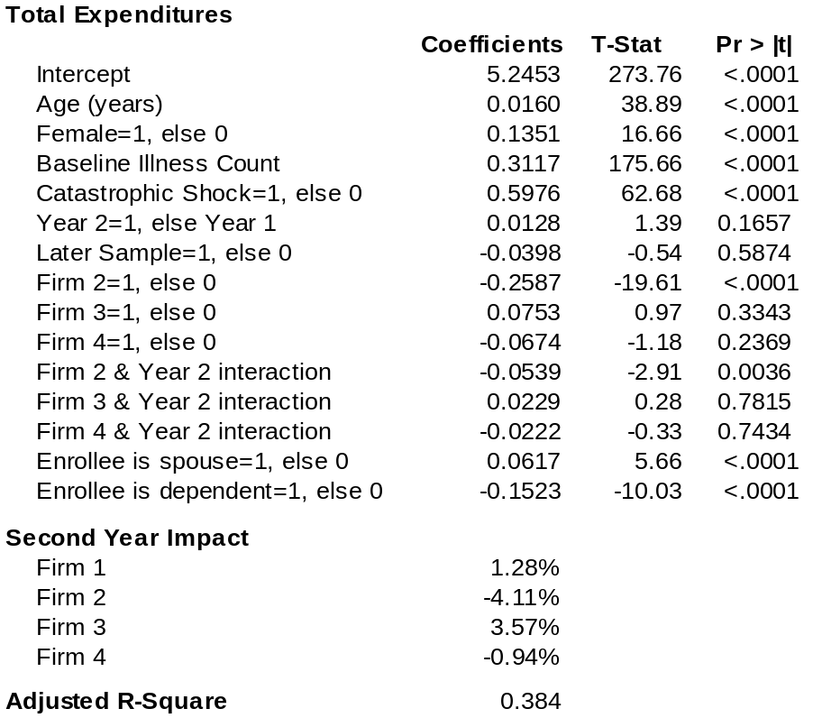

Table A2 – CDHP Replacement Effect: Total Medical Expenditures
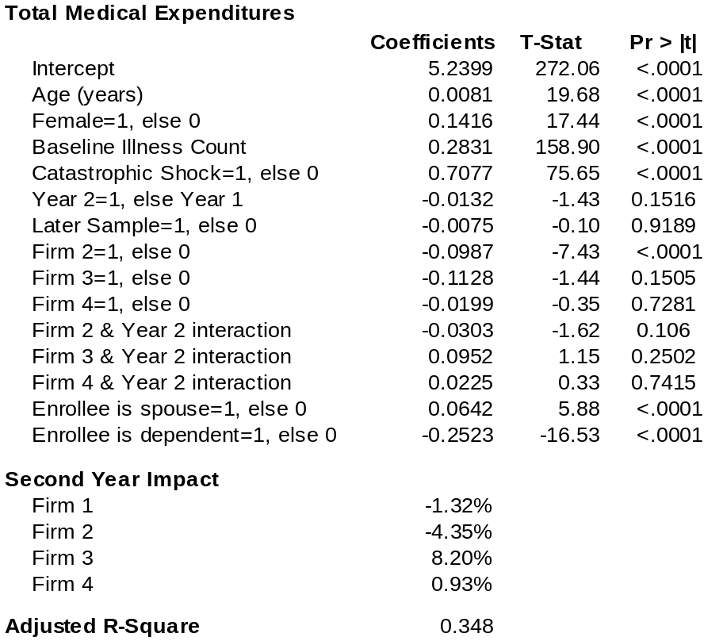
Table A3 – CDHP Replacement Effect: Consumer Out-of-Pocket Medical Expenditures
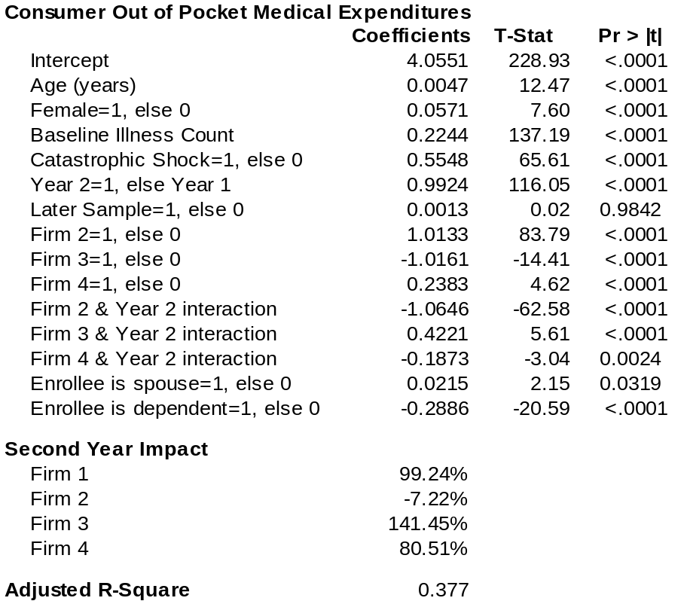
Table A4 – CDHP Replacement Effect: Total Pharmacy Expenditures
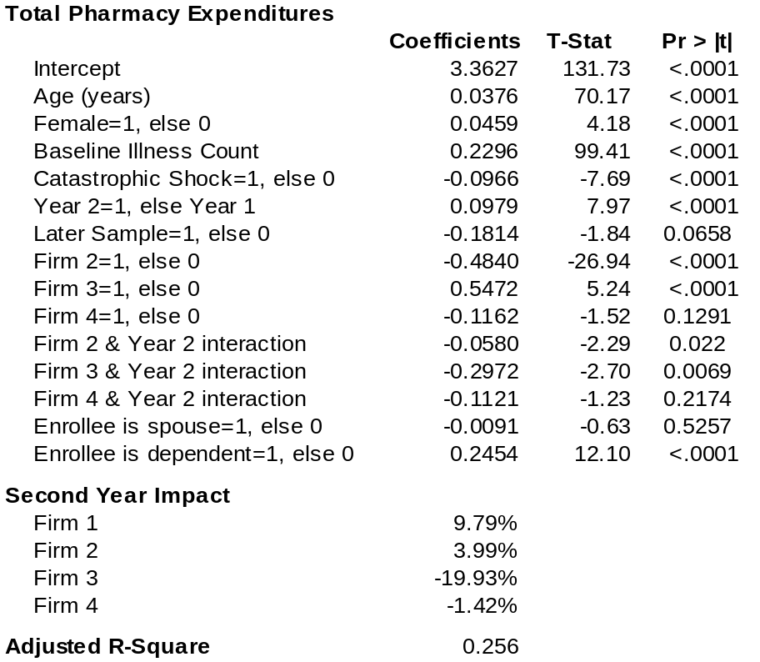
Table A5 – CDHP Replacement Effect: Consumer Out-of-Pocket Pharmacy Expenditures
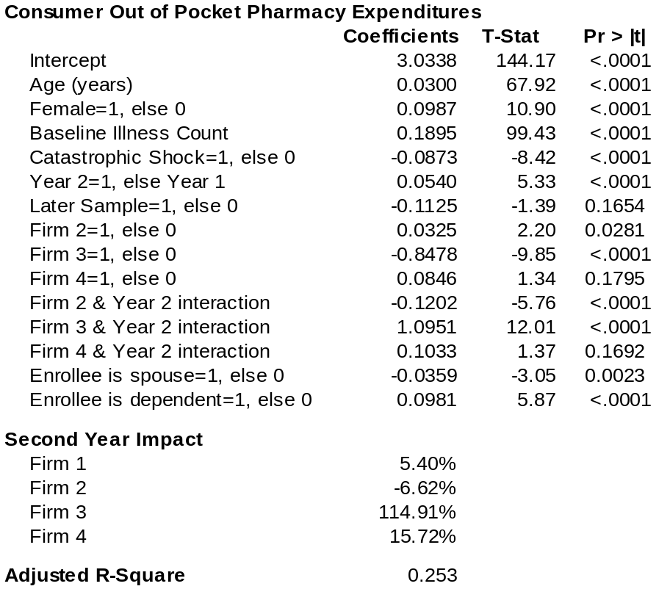
Table A6 – CDHP Replacement Effect: Probability of Preventive Visit
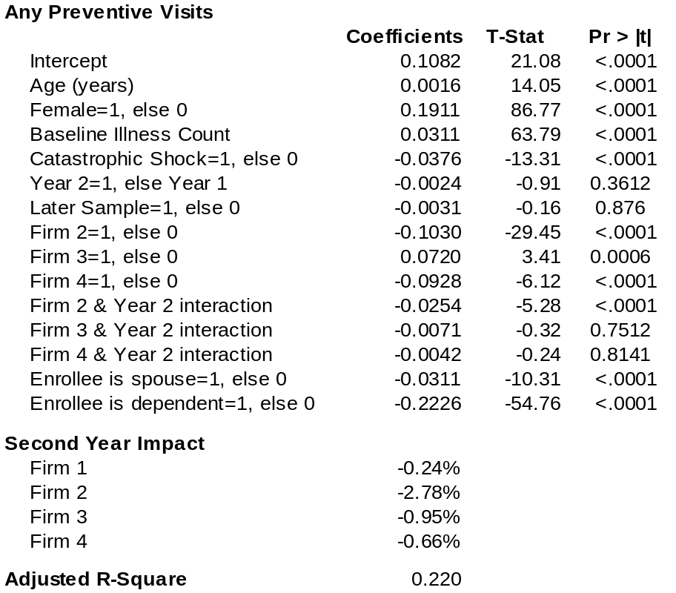
Table A7 – CDHP Replacement Effect: Probability of Colonoscopy Screening
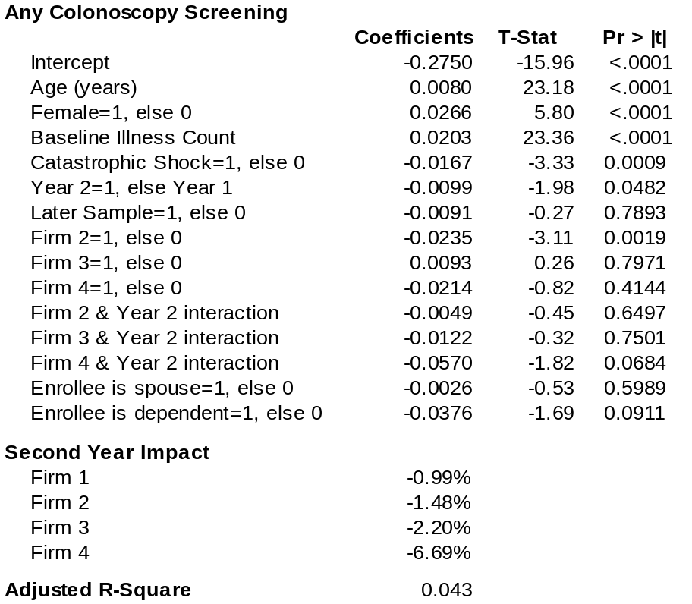
Table A8 – CDHP Replacement Effect: Probability of Cervical Cancer Screening
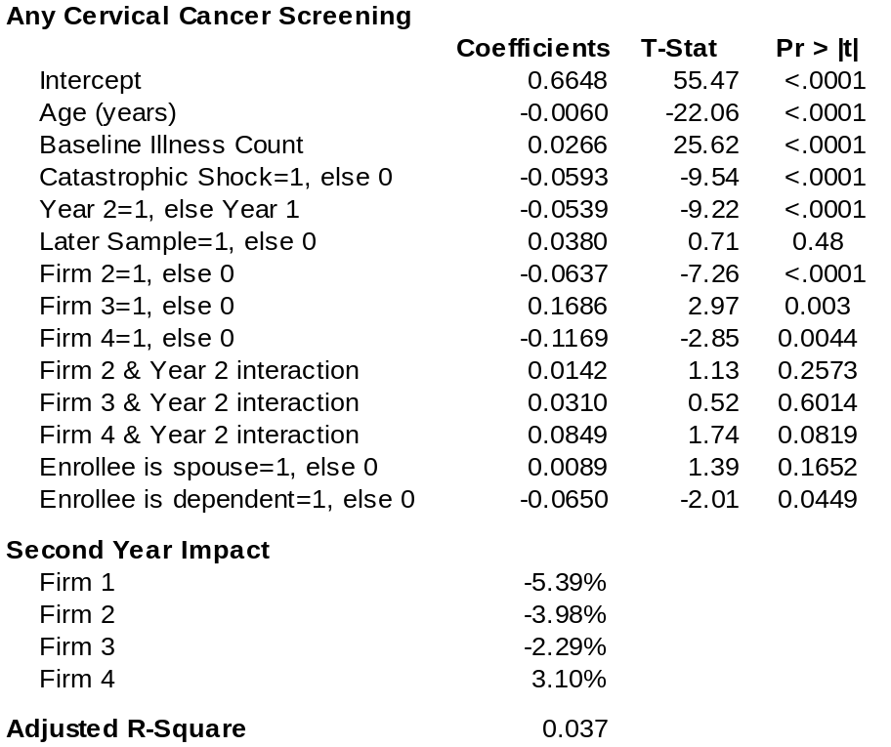
Table A9 – CDHP Replacement Effect: Probability of Mammography Screening
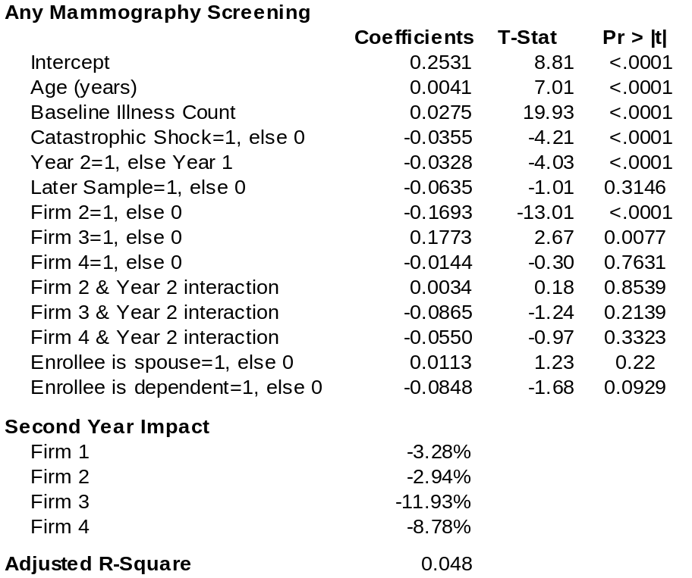

It is important to note the difference between consumer driven health plans (CDHPs) and high deductible health plans (HDHPs). A HDHP would be considered a CDHP if it also features an account for first dollar coverage such as a Health Reimbursement Arrangement (HRA) or a Health Savings Account (HSA).
The difference between an HRA and an HSA is that the consumer own the account as actual financial asset dedicated for medical care expenditure. In contrast, an HRA is a notional account that represents funds made available by an employer to an employee for medical care. Typically, an employee with an HRA can not leave an employer with any accumulated or remaining balance in the HRA. Both HRAs and HSAs allow consumers to accumulate unused account resource for use in a subsequent year.
Overall illness burden is based on a count of Ambulatory Diagnostic Groups (ADGs) in the base year of observation and derived from an algorithm described by Weiner et al (1991). Catastrophic shock is a concurrent year variable based on the presence of an ADG where the patient had a major acute care event, cancer diagnosis, injury or trauma.
Each of the results represents coefficients used in Tables A1 to A9. In all cases the statistics represent the sum of an interaction between the second year effect and the firm of interest interacted with the second year effect.
Prior work (Parente, Feldman, and Chen, 2008) has shown that the bootstrapped significance is smaller than the non-bootstrapped method.

